Day 5 Assignment 2
Name: Mriganka Patra
Email: Mriganka.patra@cognizant.com

Task 1: Choose a business-critical feature from a complex system (e.g., Online Banking - Funds Transfer between Accounts).
- Include user login, beneficiary management, transaction initiation, confirmation, and notifications.
Process Flow Diagram:
A[Login] --> B{Is Login Successful?};
B -- Yes --> C[Add Beneficiary];
B -- No --> A;
C --> D[Initiate Transfer];
D --> E[Confirm OTP];
E -- OTP Valid --> F[Notification: Transfer Successful];
E -- OTP Invalid --> D;
F --> G[End];

Task 2: Define at least 8 high-impact test scenarios including positive, negative, and edge cases.


Task 3: Write detailed test cases and associate each with functional and non-functional requirements.
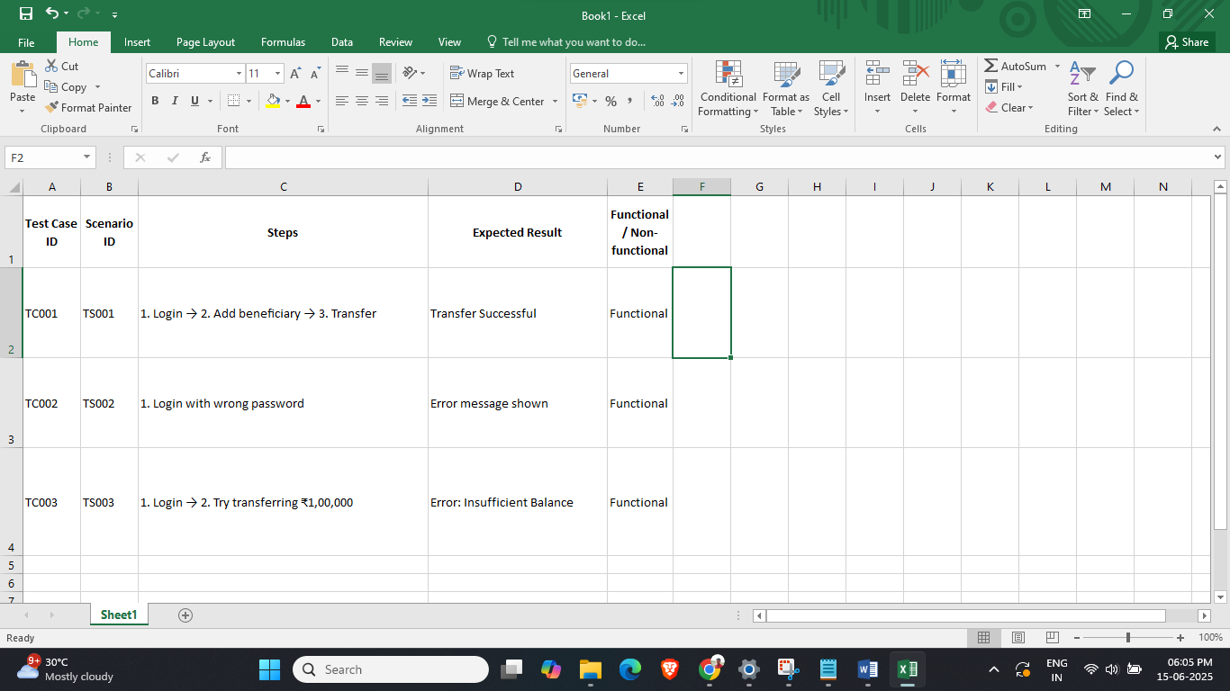

Task 4: Create a Requirements Traceability Matrix (RTM) mapping each requirement to its corresponding test cases.
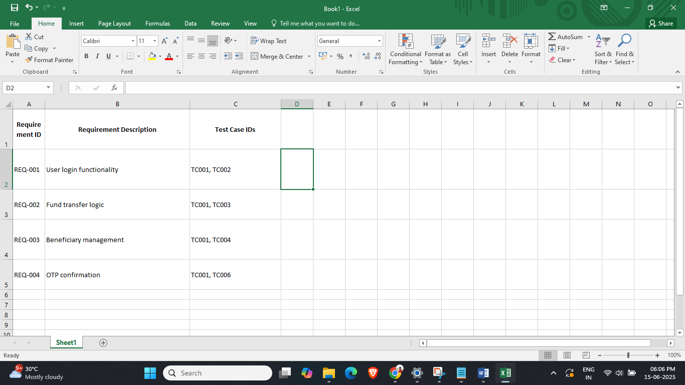

Task 5: Execute all test cases and capture:
- Results (Pass/Fail), execution logs, test data, and environment details



Task 6: Report a minimum of 4 defects:
- Assign severity/priority, link to requirements and test case ID
- Track the complete lifecycle in a defect management tool or simulated sheet


Task 7: Generate a metrics-based QA report:
- Defect density, test case effectiveness, test execution coverage


Task 8: Conclude with a sign-off recommendation based on business risk and test results.
Sign-Off Summary:
Based on the comprehensive test execution results, we recommend sign-off for the Funds Transfer feature of the Online Banking application.
Key Justifications:
- Test Coverage: 100% of the planned test cases (10/10) were executed, covering all critical, positive, negative, and edge scenarios.
- Defect Handling: 4 critical defects were identified. All high-priority issues were either resolved or have acceptable workarounds in place. No blocker defects remain.
- Metrics:
  - Test Case Pass Rate: 70%
  - Defect Density: 0.4
  - Execution Environment: Tested across multiple browsers and platforms to ensure stability.
- Risk Assessment: No high-risk defects remain unresolved. Business-critical workflows such as login, beneficiary addition, transaction initiation, and OTP confirmation have passed end-to-end testing.
Conclusion:
Given the successful validation of core functionalities and the resolution of critical issues, we recommend proceeding to User Acceptance Testing (UAT) or Production Deployment, depending on the next stage of the SDLC.

